Project Name: Supermarket Billing System

Date: 10-12-2023

Copyright Notice
This document contains proprietary information of HCL Technologies Ltd. No part of this document may be reproduced, stored, copied, or transmitted in any form or by means of electronic, mechanical, photocopying or otherwise, without the express consent of HCL Technologies. This document is intended for internal circulation only and not meant for external distribution.
Revision History
Version No | Date | Prepared by / Modified by | Significant Changes
Billing 1.0 | 27/11/2023 | GROUP – 2 | Accepts invalid data
Billing 2.0 | 3/11/2023 | GROUP – 2 | Accepts only valid data and invalid data input shows error message

Table Of Contents
1.1 Project Overview 3
1.2 Scope 3
1.3 Out of Scope 3
1.4 Intended Audience 3
1.5 High Level Use Cases 3
1.6 Use Cases detailed 3
1.7 User Interface Modules 3
1.8 Technical Architecture 3
1.9 Technical Detailed Description 3
1.10 Sequence Diagram 3
1.11 Database Entity Relationship Diagram 3
1.12 Standards 3
1.13 Non Functional Requirements 3

Project Overview
The Supermarket and Billing System is meticulously crafted to elevate the efficiency of supermarket operations, seamlessly managing sales, and billing processes. Imagine a system that simplifies the entire shopping experience for both customers and staff. It ensures that the checkout process is swift, with sales handled effortlessly. Each customer's preferences and purchase history are tracked, creating a personalized shopping experience. The billing process becomes straightforward, eliminating any complexities during check-out. The system aims to create a seamless shopping experience, from entry to exit, providing a reliable and enjoyable shopping journey. Behind the scenes, it acts as a diligent record-keeper, maintaining a systematic record of all supermarket activities like discount products and products in cart. In essence, the Supermarket Billing System is the comprehensive solution for running a supermarket smoothly, acting as a reliable companion who takes care of all the details, allowing both customers and staff to focus on what matters most – an exceptional shopping experience.

Scope

The Supermarket and Billing System aim to streamline the operations of sales, and billing. It focuses on providing efficient services to customers and maintaining an organized record of supermarket activities.
Module Name | Application Roles | Description
Products | Customer/Staff | Perform the sales transaction of every item in the supermarket.
Generation of bill | Customer/Staff | Bill generated for every item purchased by the customer.
Discount Products | Customer/Staff | Update the inventory when an item is sold, items are brought into the supermarket.

.

Out of Scope
Online Shopping
Home Delivery
Supplier Management

Intended Audience
Data Carriers:

Analysts gathering and organizing documentation related to data carriers.
Questionnaires for efficient responses from a large number of people.
Personal Interviews to understand customer needs.
Observation for observing ongoing system operations.

High Level Use Cases
Product Management:

Actor: Staff
Description: Staff can add and manage products in the supermarket inventory, including details such as product name, price, and quantity.
Checkout Process:

Actor: Cashier
Description: Cashiers can efficiently handle the checkout process, scan products, and generate bills for customers.
Customer Loyalty Program:

Actor: Staff
Description: Staff can track customer preferences, manage loyalty programs, and provide personalized recommendations based on purchase history.

User Interface Modules
2. Testing Phases
2.1 Unit Testing:
In the Supermarket and Billing System, Unit Testing ensures the functionality of individual components, mirroring the process of checking ingredients before creating a dish.

Self-Review: Developers review their code for correctness.
Peer Review: Another team member tests the code for a fresh perspective.
SQA Review: Rigorous examination by the Software Quality Assurance team.
2.2 Integration Testing:
This phase combines tested units into larger aggregates using approaches like Big Bang, Bottom-Up, and Top-Down.

2.3 Alpha Testing:
Customers explore the application in a controlled environment, providing feedback for swift improvements.

2.4 System Testing:
Ensures accurate system operation before live operations begin.

2.5 Validation Testing:
Validates that the system aligns with requirements and fulfills organizational goals.

Technical Architecture
1. System Design Approach:
The technical architecture of the Supermarket and Billing System is designed to provide a robust and scalable solution for managing supermarket operations. The design approach involves a systematic breakdown into logical and physical design phases.

1.1 Logical and Physical Design Phases:
Logical Design:

Utilizes Data Flow Diagrams (DFD) to illustrate the flow and boundaries of the system.
Defines the information flow, outlining how data moves through the system.
Guides the development team in understanding the high-level structure of the system.
Physical Design:

Reviews the existing physical system, identifying areas for improvement.
Establishes output specifications, edit controls, security measures, and an implementation plan.
Walkthrough of information flow, output, input controls, and the implementation plan for a comprehensive understanding.
1.2 Creative Essence of Software Design:
Emphasizes creativity in software design to enhance the quality and accuracy of the final product.
Outlines how the system meets identified requirements and shapes input data and master files for proposed output needs.
Logical design determines how outputs are produced and in what format.
2. Phases in System Design:
The system design phase encompasses critical steps:

Review of the Current Physical System:

Comprehensive analysis to identify strengths and weaknesses in the existing system.
Output Specification:

Detailed definition of output formats, content, and frequency of reports.
Terminal specifications for efficient communication with users.
Input Specification:

Transformation of user-oriented input into a computer-based format.
Ensures error-free data entry operations.
Edit Control and Security Specification:

Definition of measures to ensure data integrity and system security.
Implementation of controls for editing and securing data.
Implementation Plan:

Detailed plan outlining the deployment and integration of the system.
Addresses practical aspects of introducing the system into the supermarket environment.
Logical Design Walkthrough:

Comprehensive walkthrough covering information flow, output, input controls, and the implementation plan.
Ensures a holistic understanding of the system's workings.
3. Input Design:
Transforms user-oriented input into a computer-based format.
Ensures error-free data entry operations and specifies how data is fed into the system.
4. Output Design:
Designs computer outputs, such as reports, aligned with user requirements.
Enhances the system's relationship with users and facilitates decision-making for management.
5. Database Design:
Central to the system's functionality, the database design ensures efficient data management.
Manages shared data across applications, aiming for fast response times, information availability, and redundancy control.
Conclusion:
The technical architecture of the Supermarket and Billing System is crafted to meet and exceed industry standards. It focuses on logical and physical design phases, emphasizing creativity in software design, and ensures efficiency in data management through a well-designed database. This architecture serves as the foundation for a scalable, reliable, and innovative solution for supermarket operations.

Technical Detailed Description

Technical Detailed Description
System Solution and Approach:
The Supermarket and Billing System is architected with a comprehensive approach, addressing the specific needs of supermarket operations. The design philosophy revolves around providing an integrated solution that enhances operational efficiency and delivers an exceptional shopping experience.

Logical and Physical System Design:
The development process encompasses two crucial phases: logical design and physical design.

Logical Design:

Defines the system's flow through detailed diagrams.
Establishes operational boundaries.
Utilizes Data Flow Diagrams (DFD) for a profound understanding.
Physical Design:

In-depth review of the existing physical system.
Creation of output specifications, including format, content, and frequency.
Configuration of edit controls, security measures, and an implementation plan.
Creative Aspect of Software Design:
Creativity plays a pivotal role in shaping the Supermarket and Billing System. This phase ensures the quality and accuracy of the final product. It determines how the system meets identified requirements, shaping input data and master files to align with proposed output needs.

System Development Phases:
Review of Current System:

Comprehensive analysis of the existing physical system.
Identification of areas for improvement and enhancement.
Output Specification:

Detailed specifications defining the format, content, and frequency of reports.
Terminal specifications for efficient user interaction.
Input Specification:

Crafted to ensure error-free data entry operations.
Tailored to meet specific needs for the proposed output.
Edit Control and Security Specification:

Measures defined to ensure the integrity and security of the system.
Controls for editing and securing data.
Implementation Plan:

Detailed plan outlining the deployment process.
Addresses practical aspects of integrating the system seamlessly.
Logical Design Walkthrough:

A walkthrough covering information flow, output, input controls, and the implementation plan.
Ensures a comprehensive understanding of the system's workings.
Input Design:
This phase focuses on converting user-oriented input into a computer-based format. It ensures error-free data entry operations and specifies how data is fed into the system.

Output Design:
Computer output design is a meticulous process, aligning with user requirements. Well-crafted output enhances the system's relationship with users and aids decision-making for supermarket management.

Database Design:
At the core of our system, the database design is crucial for efficient data management. Shared across applications, the database handles data as an entity, emphasizing fast response times, information availability, and redundancy control.

Technical Architecture:
The Supermarket and Billing System's technical architecture is the backbone of its functionality. The design ensure the system meets and exceeds industry standards, setting new benchmarks for efficiency and innovation.

Sequence Diagram
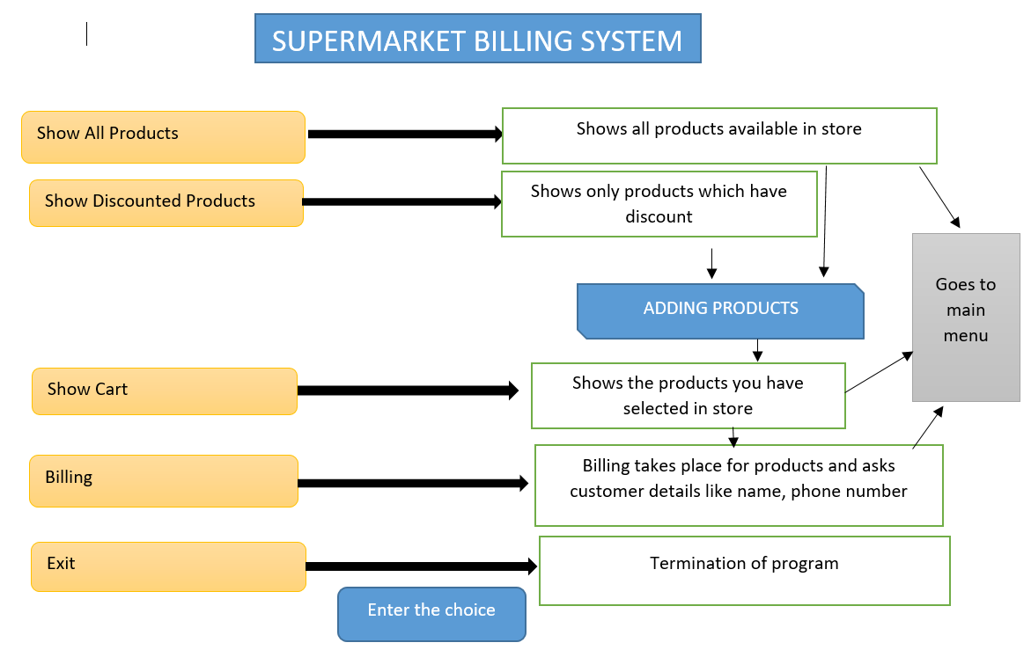

Database Entity Relationship Diagram
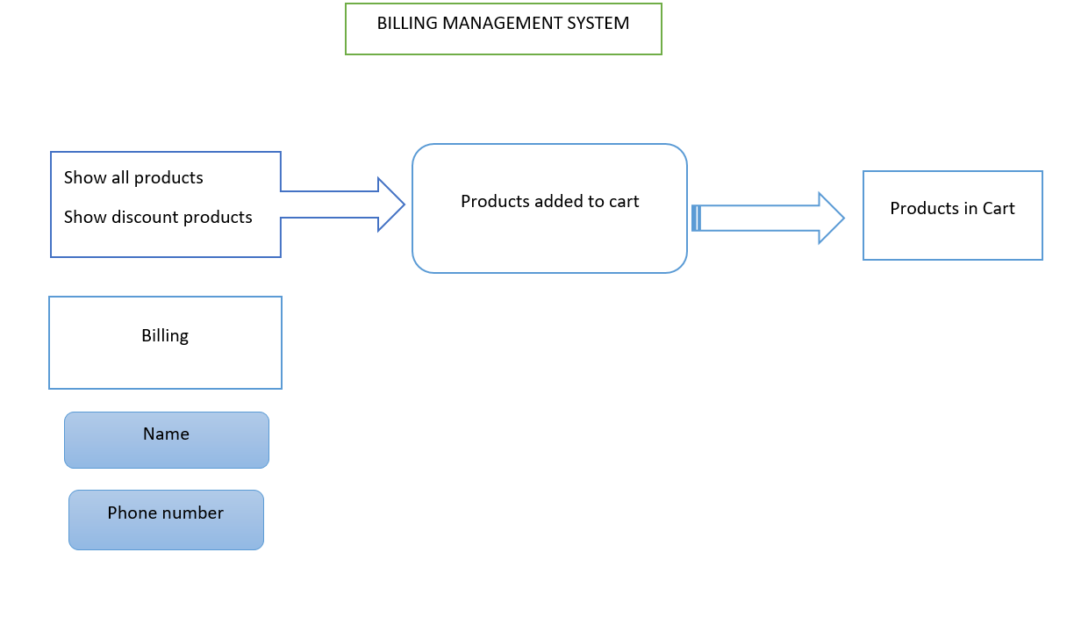

Standards
User Interface Standards:

Consistent layout and color scheme.
Intuitive navigation complying with accessibility standards.
Coding Standards (Java):

Follow Java Naming Conventions.
Implement proper exception handling.
Database Design Standards:

Normalize the database to reduce redundancy.
Follow ACID properties for consistency.
Security Standards:

Implement encryption for sensitive data.
Apply role-based access control.
Performance Standards:

Optimize database queries.
Implement caching mechanisms.
Documentation Standards:

Maintain comprehensive code documentation.
Use Javadoc for inline documentation.
Testing Standards:

Adopt Test-Driven Development.
Perform regular regression testing.
Compliance Standards:

Adhere to relevant industry regulations.
Ensure GDPR compliance.

Non Functional Requirements
Performance:

Handle a minimum of 1000 concurrent users.
Response time within 2 seconds.
Scalability:

Scalable to accommodate a 20% annual increase in users.
Database capacity for at least 1 year of data.
Reliability:

Usability:

Intuitive user interface requiring minimal training.

Compatibility:

Compatible with popular web browsers.
Mobile responsiveness for various devices.

Maintainability:

Well-documented code.
Support seamless updates and patches.

Auditability:

Logging of all user actions for auditing.

Conclusion: The transition to the Supermarket and Billing System involves adapting the existing framework to cater to the unique requirements of supermarket operations. The outlined standards and testing phases ensure the development of a robust and efficient system for supermarket management.

